Group 3:

Palak Agrawal

Tejesh Rathi

Sonali Chaudhari

Abstract

All the PL/SQL Procedures, Triggers, Functions and Cursors are listed with its result set

IMDB

Internet Movie Database

-----------------------------------------------------------------------------------------

/*Executing InsertOnPerson trigger which in turn calls createPersonAccount proc in which ufnGetUserNameFromEmail() function is called and password is encrypted using key*/

-----------------------------------------------------------------------------------------

INSERT INTO PERSON.PERSON VALUES (27,106,1112,'Sunita','Agrawal','Female','Individual',45,CURRENT_TIMESTAMP,'palak_a');

select * from PERSON.Person where PersonID = 27;

select * from PERSON.EmailAddress where PersonID = 27;

select * from PERSON.PersonAccount where PersonID = 227;

UPDATE PERSON.Person SET FirstName = 'Sarla', LastName = 'Agrawal' WHERE PersonID = 27;

|  |
| --- |
| CREATE FUNCTION PERSON.ufnGetUserName(@EmailAddress VARCHAR(50))  RETURNS VARCHAR(10)  AS  -- Returns the USERNAME ON THE BASIS OF EMAIL ADDRESS  BEGIN  DECLARE @ret VARCHAR(10);    SET @ret = SUBSTRING(@EmailAddress,1,CHARINDEX('@',@EmailAddress)-1);    IF(LEN(@ret) > 10)  SET @ret = LEFT(@ret, 10);  IF (@ret IS NULL)  SET @ret = 'dummy123';    RETURN @ret;  END; |
| USE [IMDB]  GO  /****** Object: StoredProcedure [PERSON].[createPersonAccountOnInsertOrUpdate] Script Date: 12/8/2016 2:55:37 PM ******/  SET ANSI_NULLS ON  GO  SET QUOTED_IDENTIFIER ON  GO  ALTER PROCEDURE [PERSON].[createPersonAccountOnInsertOrUpdate] @I_FIRSTNAME VARCHAR(50)  , @I_LASTNAME VARCHAR(50)  , @I_PERSONID INT  , @I_ACCOUNTNUM VARCHAR(7)  , @I_EMAILADDRESS VARCHAR(50)  AS  BEGIN    DECLARE @L_PASSWORD VARBINARY(128);  DECLARE @L_USERNAME VARCHAR(10);  DECLARE @L_MESSAGEBODY VARCHAR(100);  DECLARE @ERR_MSG VARCHAR(200);  DECLARE @ERR_STA SMALLINT;  DECLARE @ROWCOUNT INT;  -- SETTING AN INITIAL VALUES OF @ERR_MSG AND @ERR_STA  SELECT @ERR_MSG = ERROR_MESSAGE(),  @ERR_STA = ERROR_STATE();  SET @ERR_MSG= 'Error occurred while deleting from SalesOrderDetails' + @ERR_MSG;  SET @L_USERNAME = (SELECT PERSON.ufnGetUserName(@I_EMAILADDRESS));    OPEN SYMMETRIC KEY Password_Key0912  DECRYPTION BY CERTIFICATE UserPwd0912;      SET @L_PASSWORD = (SELECT EncryptByKey(Key_GUID('Password_Key0912'),  @L_USERNAME, 1, HashBytes('SHA1', CONVERT( varchar, @L_USERNAME))));    SET @L_MESSAGEBODY = 'Hi, Please remember your username: ' + @L_USERNAME +' and password: ' + @L_USERNAME;  BEGIN TRY  BEGIN TRANSACTION;  SET @ROWCOUNT = (SELECT COUNT(*)  FROM PERSON.PersonAccount  WHERE PersonID = @I_PERSONID);  IF(@ROWCOUNT = 0)    INSERT INTO PERSON.PersonAccount (PersonID,UserName,AccountNumber,CreateDate,ModifiedDate,ModifiedBy,Password) VALUES (@I_PERSONID,@L_USERNAME,@I_ACCOUNTNUM,CAST(GETDATE() AS DATE),CURRENT_TIMESTAMP,'palak_a',@L_PASSWORD);    ELSE    UPDATE PERSON.PersonAccount  SET UserName = @L_USERNAME, Password = @L_PASSWORD  WHERE PersonID = @I_PERSONID;  EXEC msdb.dbo.sp_send_dbmail @profile_name = 'IMDBAdministrator',  @recipients = @I_EMAILADDRESS,  @body = @L_MESSAGEBODY,  @subject = 'Congratulations - IMDB Account Created';  COMMIT TRANSACTION;  END TRY  BEGIN CATCH  BEGIN  PRINT ERROR_MESSAGE();  RAISERROR ('Due to some error while insertion, transaction is being rolledback',16,0);  END  ROLLBACK TRANSACTION;  END CATCH;  END |
| USE [IMDB]  GO  /****** Object: Trigger [PERSON].[InsertOnUpdateOrInsertPerson] Script Date: 12/8/2016 2:32:19 PM ******/  SET ANSI_NULLS ON  GO  SET QUOTED_IDENTIFIER ON  GO  ALTER TRIGGER [PERSON].[InsertOnUpdateOrInsertPerson]  ON [PERSON].[Person]  AFTER INSERT,UPDATE  AS  BEGIN TRY  DECLARE @firstname VARCHAR(50);  DECLARE @lastname VARCHAR(50);  DECLARE @personId INT;  DECLARE @emailAddress VARCHAR(50);  DECLARE @accountNum VARCHAR(7);  DECLARE @ROWCOUNT INT;    SELECT @personId = PersonID, @firstname = FirstName, @lastname = LastName FROM inserted;  SET @accountNum = '0012' + UPPER(LEFT(@firstname,3));  SET @emailAddress = (SELECT EmailAddress  FROM PERSON.EmailAddress  WHERE PersonID = @personId);  SET @ROWCOUNT = (SELECT COUNT(EmailAddress)  FROM PERSON.EmailAddress  WHERE PersonID = @personId);  BEGIN TRANSACTION  IF(@ROWCOUNT = 0)  BEGIN  SET @emailAddress = LOWER(@firstname) + '.' +LOWER(@lastname) + '@husky.neu.edu';  INSERT INTO PERSON.EmailAddress (PersonID, EmailAddress,ModifiedDate,ModifiedBy) VALUES (@personId,@emailAddress, CURRENT_TIMESTAMP,'palak_a');  END  EXEC PERSON.createPersonAccountOnInsertOrUpdate @I_FIRSTNAME = @firstname,  @I_LASTNAME = @lastname,  @I_PERSONID = @personId,  @I_ACCOUNTNUM = @accountNum,  @I_EMAILADDRESS = @emailAddress  COMMIT TRANSACTION  END TRY  BEGIN CATCH  IF @@TRANCOUNT>0  BEGIN  ROLLBACK TRANSACTION  RAISERROR ('Due to some error while insertion, transaction is being rolledback',16,1);  END  END CATCH; |

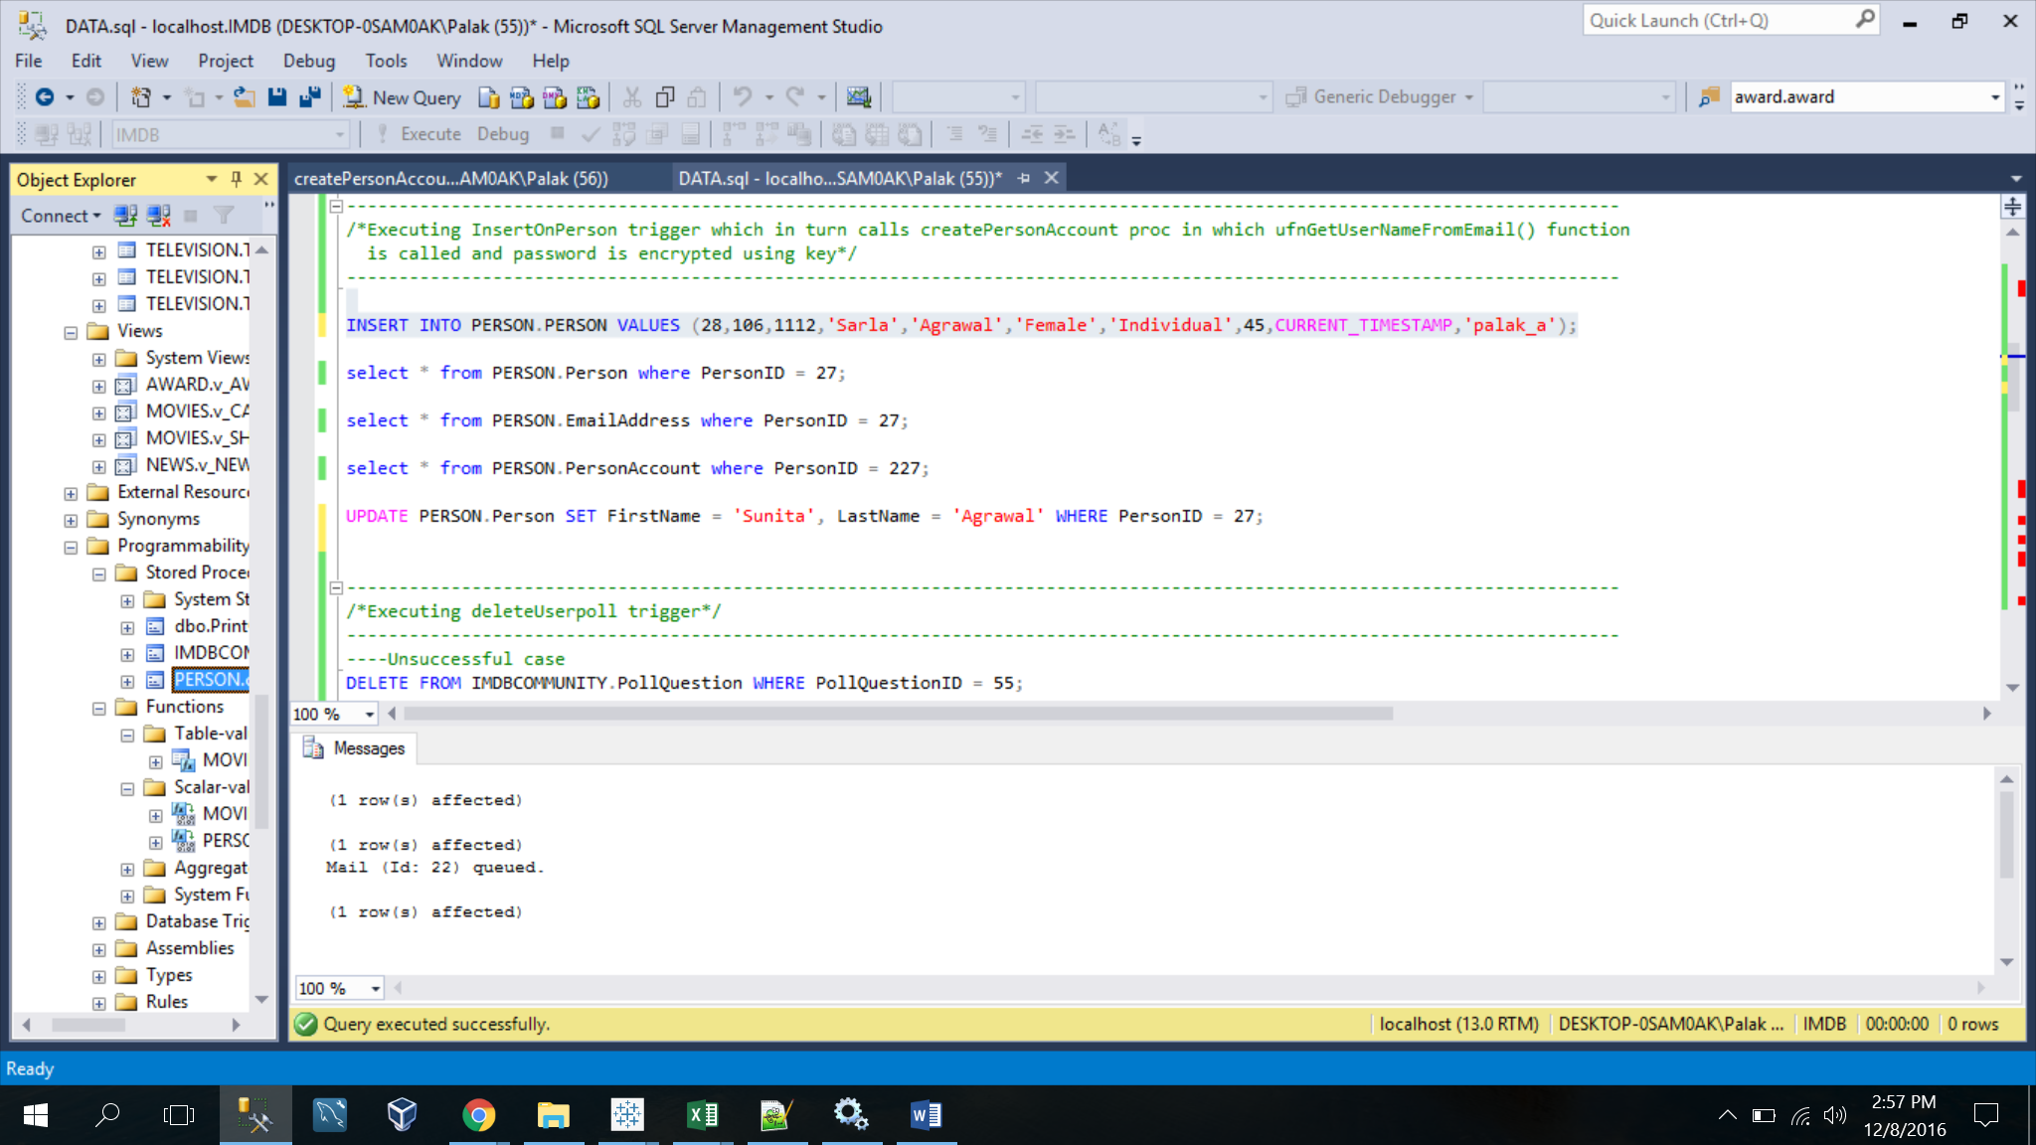

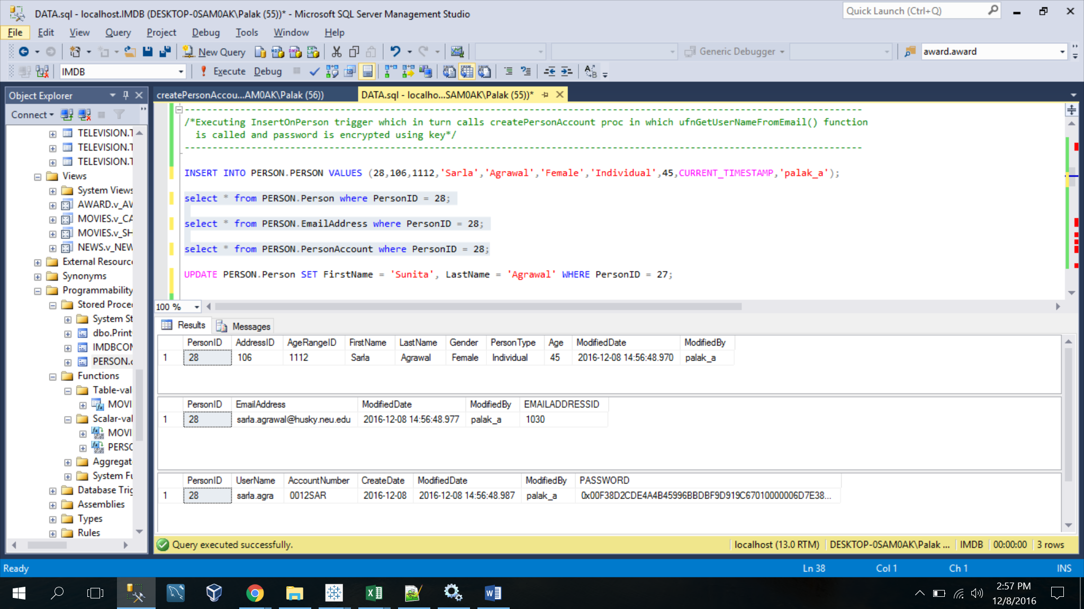

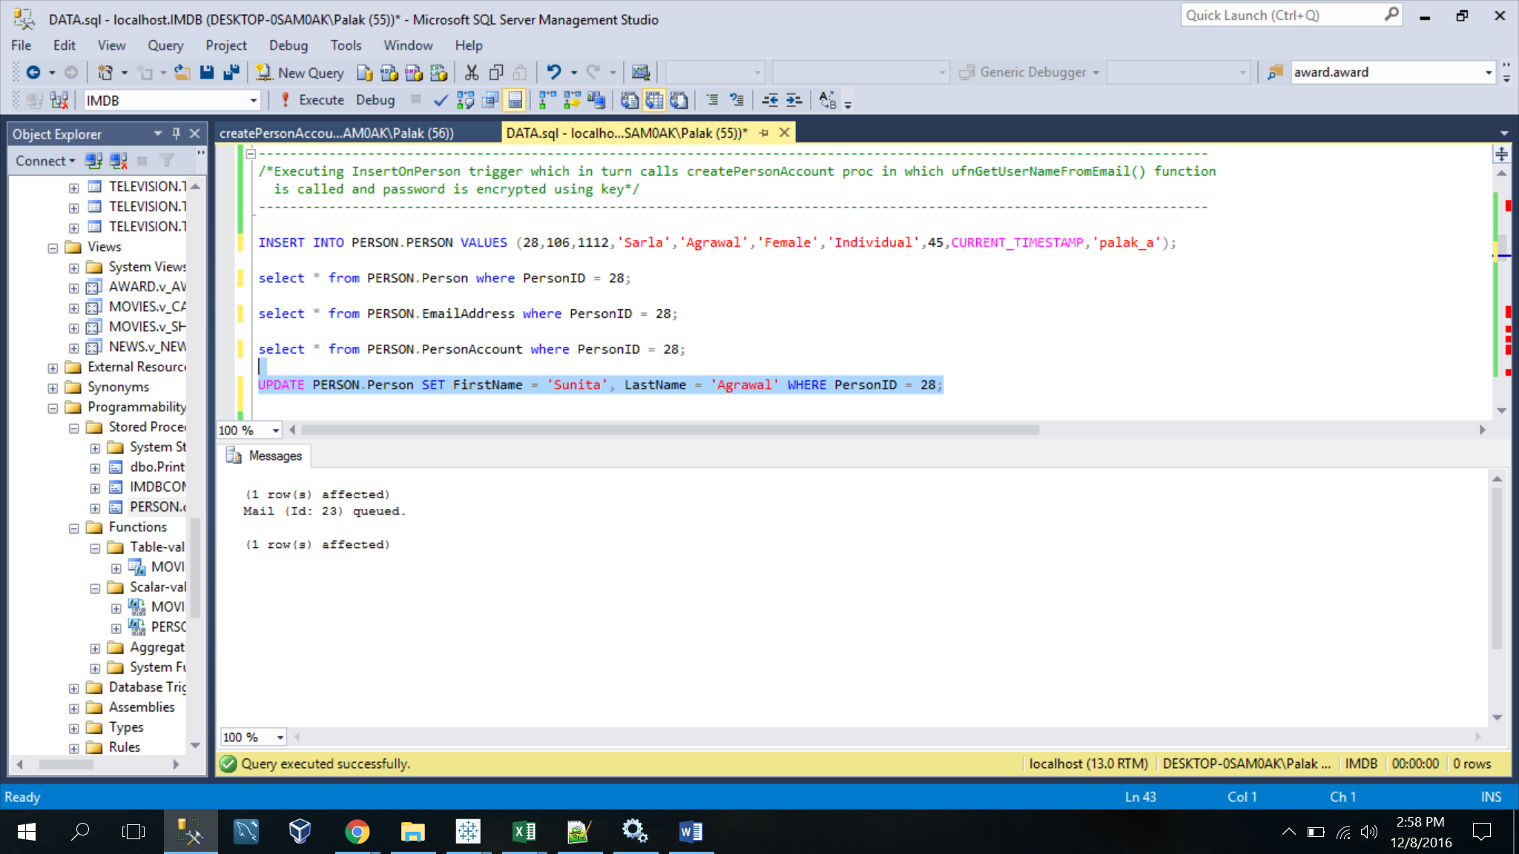

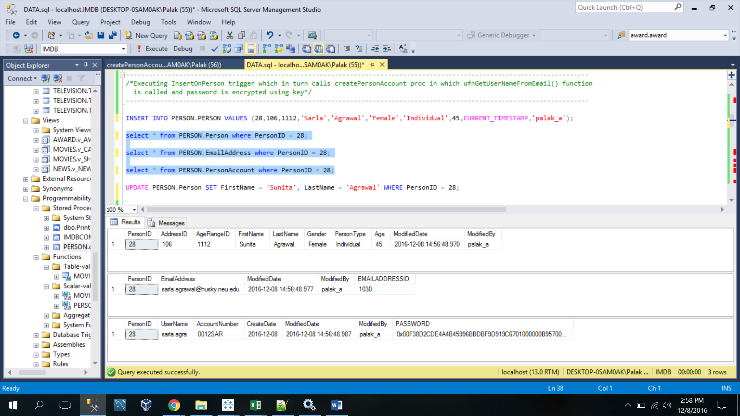

-----------------------------------------------------------------------------------------

/*Executing deleteUserpoll trigger*/

-----------------------------------------------------------------------------------------

|  |
| --- |
| CREATE TRIGGER DELETEUSERPOLL ON IMDBCOMMUNITY.POLLQUESTION  INSTEAD OF DELETE  AS  BEGIN  DECLARE @QuestionID int;  DECLARE @PostedUser varchar(30);  DECLARE @PostedDate date;  SELECT @QuestionID = PollQuestionID, @PostedUser = PostedBy, @PostedDate = PostedOn  FROM DELETED;  BEGIN TRY  IF EXISTS (SELECT @QuestionID  FROM IMDBCOMMUNITY.PollQuestion  WHERE PollQuestionID = @QuestionID  )  BEGIN  BEGIN TRANSACTION  DELETE FROM IMDBCOMMUNITY.UserPoll WHERE PollQuestionID = @QuestionID;  DELETE FROM IMDBCOMMUNITY.PollOption WHERE PollQuestionID = @QuestionID;  DELETE FROM IMDBCOMMUNITY.PollQuestion WHERE PollQuestionID = @QuestionID;  COMMIT TRANSACTION  PRINT 'The Poll question Posted by '+ @PostedUser +' on '+CAST(@PostedDate as Varchar(10))+ ' is deleted.'  END  ELSE  BEGIN  PRINT 'QuestionID does not exist';  THROW 50001,'Please enter a valid question to be deleted',1;  END  END TRY  BEGIN CATCH  IF @@TRANCOUNT>0  BEGIN  ROLLBACK TRANSACTION  RAISERROR ('The DELETE was unsuccessful due to invalid QuestionID',16,1);  END  END CATCH;  END |

----Unsuccessful case

DELETE FROM IMDBCOMMUNITY.PollQuestion WHERE PollQuestionID = 55;

---- Successful case

DELETE FROM IMDBCOMMUNITY.PollQuestion WHERE PollQuestionID = 1;

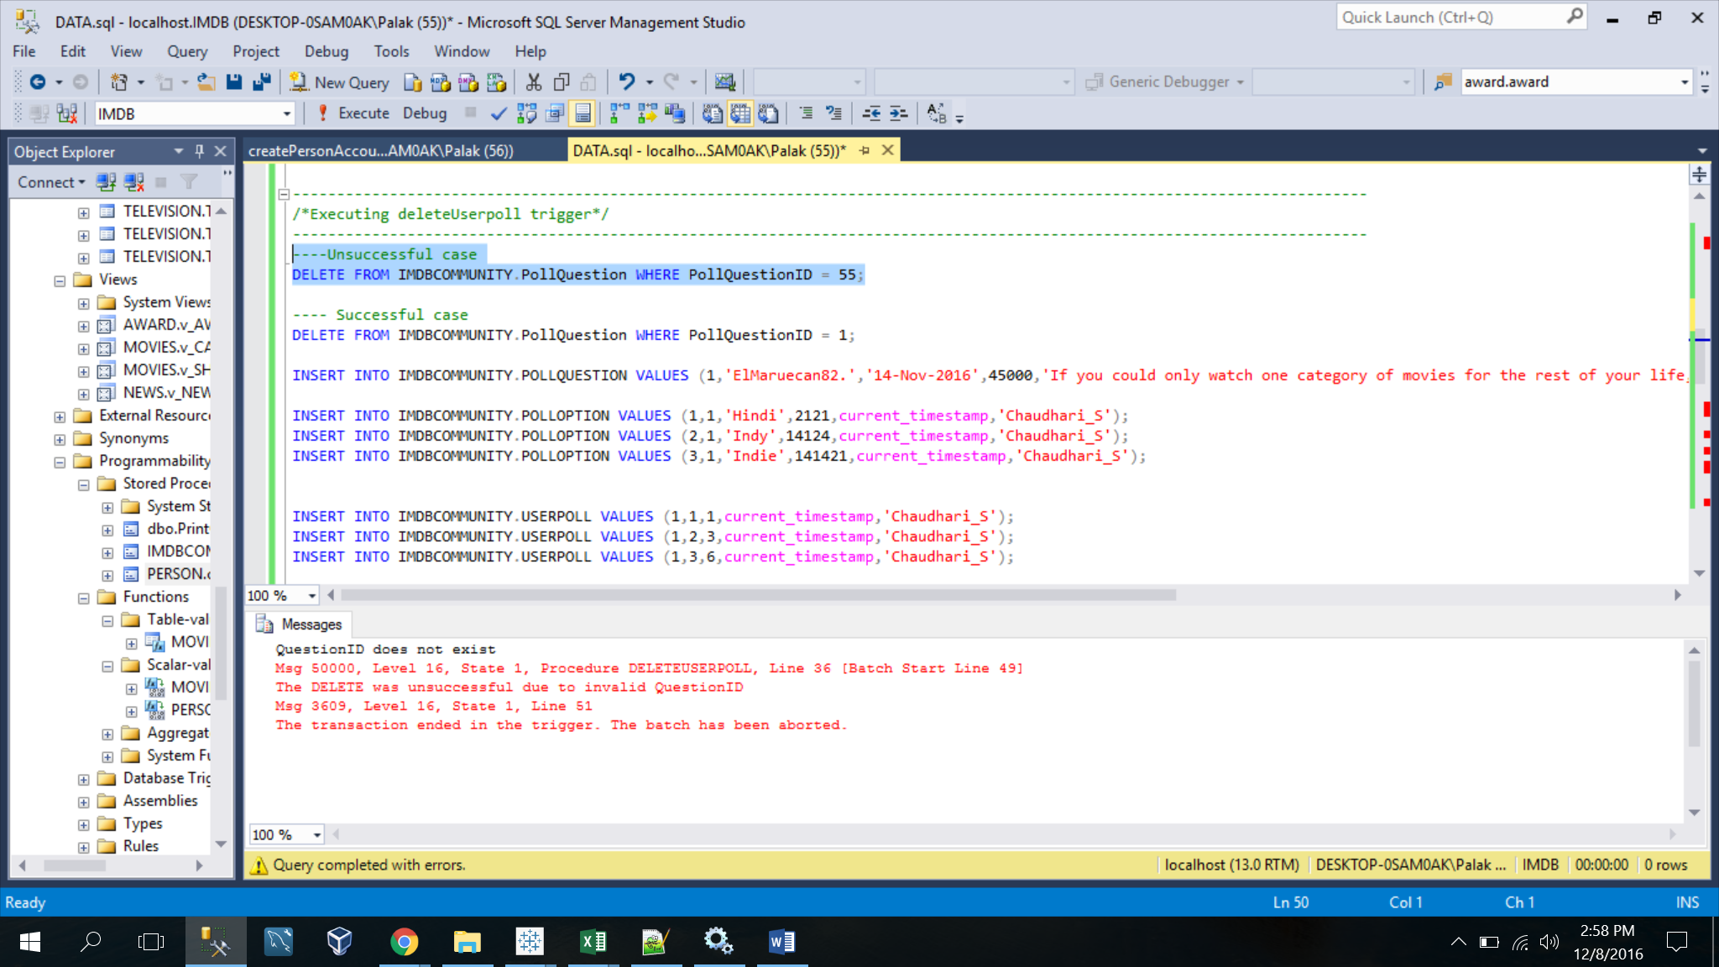

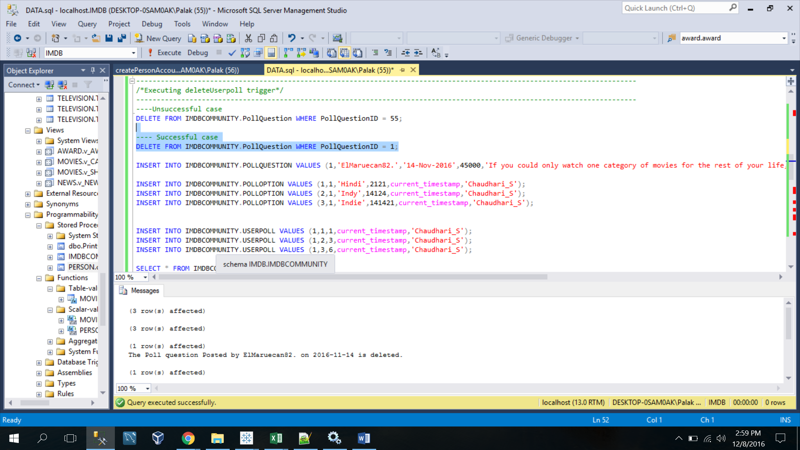

-----------------------------------------------------------------------------------------

/*Executing addmessageboard*/

-----------------------------------------------------------------------------------------

|  |
| --- |
| CREATE PROCEDURE IMDBCOMMUNITY.ADDMESSAGEBOARDS  @CategoryName varchar(100), @TopicName varchar(100), @DiscussionContent varchar(1000)  AS  BEGIN  DECLARE @CategoryID Int;  DECLARE @TopicStartDate date;  DECLARE @TopicID Int;  DECLARE @UserID Int;  SET @CategoryID = (SELECT CategoryID  FROM IMDBCOMMUNITY.MESSAGEBOARDCATEGORY  WHERE CategoryName = @CategoryName);  SET @TopicID = (SELECT TopicID  FROM IMDBCOMMUNITY.MESSAGEBOARDTOPIC  WHERE TopicName = @TopicName);  IF EXISTS(SELECT @CategoryID  FROM IMDBCOMMUNITY.MESSAGEBOARDCATEGORY  WHERE CategoryName = @CategoryName)  BEGIN  IF EXISTS(SELECT @TopicID  FROM IMDBCOMMUNITY.MESSAGEBOARDTOPIC  WHERE TopicName = @TopicName)  BEGIN  INSERT INTO IMDBCOMMUNITY.MESSAGEBOARD (TopicID,DiscussionContent,ModifiedDate,ModifiedBy,UserID) VALUES (@TopicID, @DiscussionContent,current_timestamp,'Tejesh',@UserID);  END  ELSE  BEGIN  RAISERROR ('Cannot insert the given discussion on the Message Board. Invalid TopicID',16,1);  Print 'TopicID does not exists. Please enter a valid TopicName..!!'  END  END  ELSE  BEGIN  RAISERROR ('Cannot insert the given discussion on the Message Board. Invalid CategoryID',16,1);  Print 'CategoryID does not exists. Please enter a valid CategoryName..!!'  END  END  ---EXEC IMDBCOMMUNITY.ADDMESSAGEBOARDS 'Film Talk', 'Hello', 'Best "screwball" comedies of the 1930s' |

----Unsuccessful case

EXEC IMDBCOMMUNITY.ADDMESSAGEBOARDS 'Film Talk', 'Hello', 'Best "screwball" comedies of the 1930s';

---- Successful case

EXEC IMDBCOMMUNITY.ADDMESSAGEBOARDS 'Film Talk', 'Film General', 'Best "screwball" comedies of the 1930s';

select * from IMDBCOMMUNITY.MessageBoard order by discussionid desc;

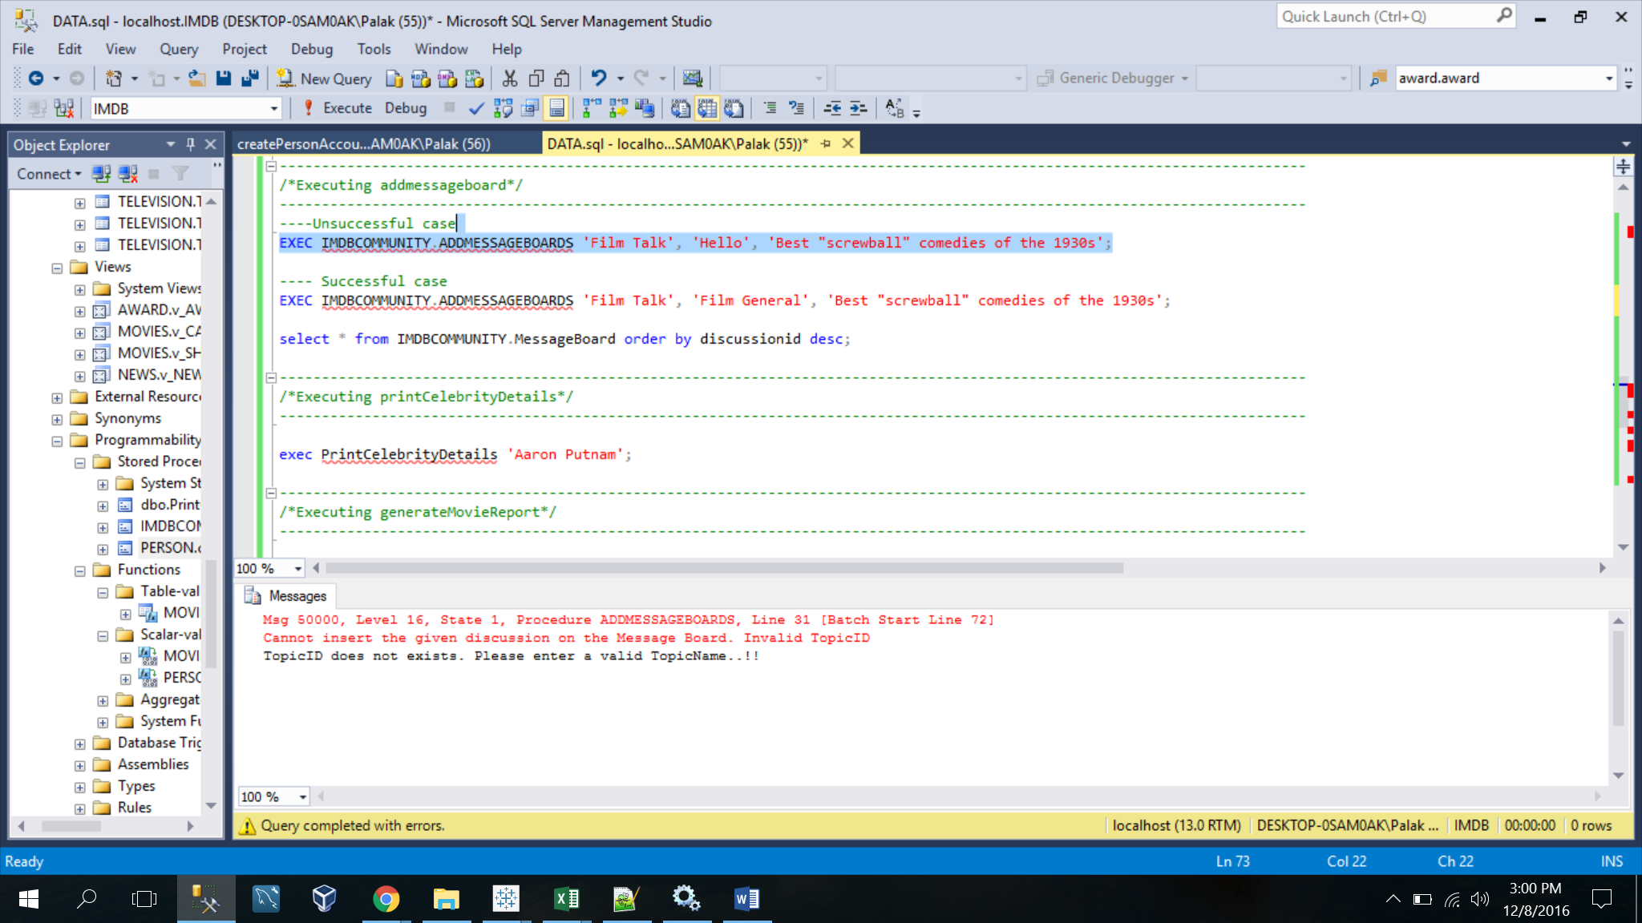

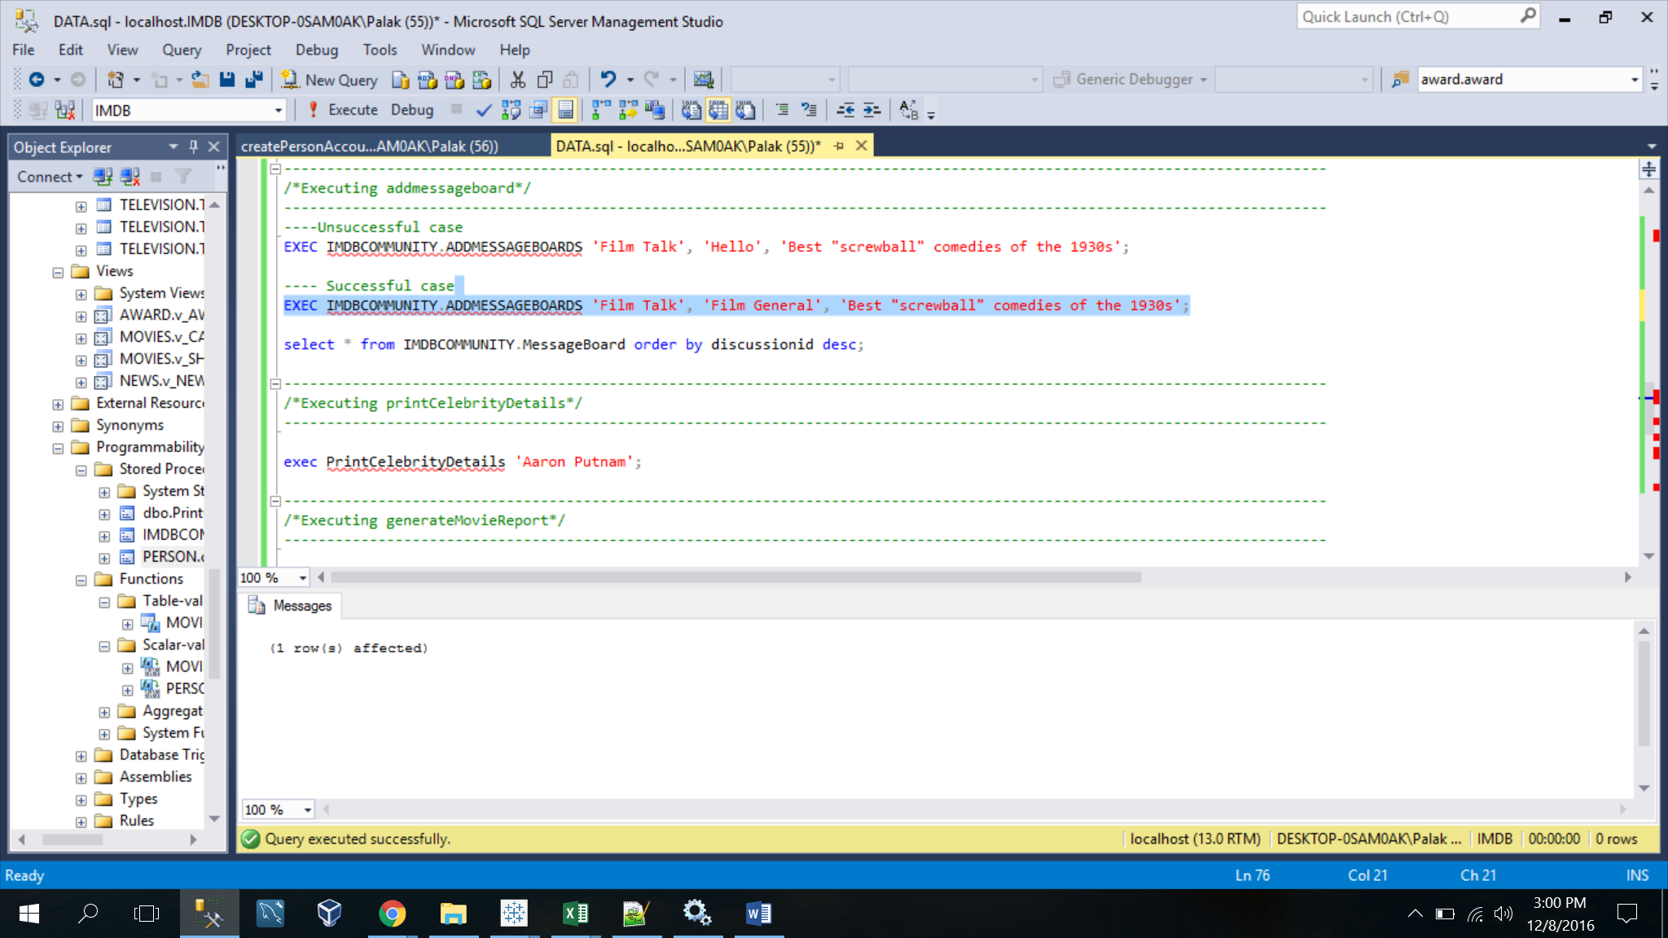

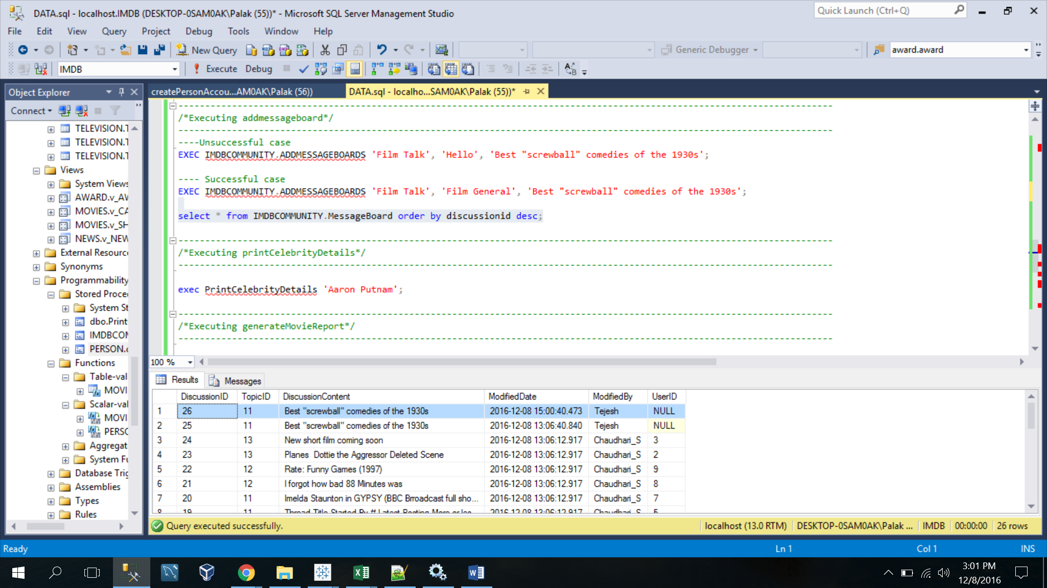

-----------------------------------------------------------------------------------------

/*Executing printCelebrityDetails*/

-----------------------------------------------------------------------------------------

|  |
| --- |
| USE [IMDB]  GO  /****** Object: StoredProcedure [dbo].[PrintCelebrityDetails] Script Date: 12/8/2016 1:03:28 PM ******/  SET ANSI_NULLS ON  GO  SET QUOTED_IDENTIFIER ON  GO  -- Get the celebrity details and history given his name  ALTER PROCEDURE [dbo].[PrintCelebrityDetails]  @CelebrityName varchar(50)  AS  BEGIN  DECLARE @MovieName varchar(50);  DECLARE @CelebrityType varchar(100);  DECLARE @MovieYear date;  DECLARE @CollectionAmount integer;  IF EXISTS(SELECT @CelebrityName  FROM PERSON.Celebrity C  WHERE C.Name = @CelebrityName)  BEGIN  DECLARE Cursor1 cursor for  SELECT CFM2.CELEBRITYNAME,  MOVIENAME,  M.MovieYear,  SUM(BCM.CollectionAmount) TOTALCOLLECTION,  STUFF((SELECT DISTINCT ', ' + CFM1.Type  FROM MOVIES.v_CASTFORMOVIE CFM1  WHERE CFM1.CELEBRITYNAME = CFM2.CELEBRITYNAME FOR XML PATH('')),1,1,'') AS CELEBTYPE  FROM MOVIES.v_CASTFORMOVIE CFM2,  MOVIES.Movie M,  MOVIES.BoxOfficeCollectionOfMovie BCM  WHERE M.MOVIEID = CFM2.MOVIEID AND  BCM.MovieID = CFM2.MovieID AND  CFM2.CELEBRITYNAME = @CelebrityName  GROUP BY CELEBRITYNAME,  MOVIENAME,  M.MOVIEYEAR  ORDER BY CELEBRITYNAME  Open cursor1;  FETCH NEXT FROM cursor1 INTO @CelebrityName, @MovieName, @MovieYear, @CollectionAmount, @CelebrityType  WHILE @@FETCH_STATUS = 0  BEGIN  PRINT '--------------------------------------------------------------------------------------------'  PRINT @CelebrityName + ' has been a part as '+@CelebrityType  PRINT 'For Movie: '+ @MovieName  PRINT 'In the year: ' + CAST(@MovieYear AS VARCHAR(4))  PRINT 'It has a Gross Box Office Collection of ' +CAST(@CollectionAmount AS VARCHAR(5)) + ' millions'  PRINT '---------------------------------------------------------------------------------------------'  FETCH NEXT FROM cursor1 INTO @CelebrityName, @MovieName, @MovieYear, @CollectionAmount, @CelebrityType  END  CLOSE cursor1  DEALLOCATE cursor1    END  ELSE  BEGIN  Print 'The Celebrity does not exist in our Database. Please enter another celebrity to get the Details'  RAISERROR('Celebrity does not match with our Database',16,0);  END  END  --EXEC PrintCelebrityDetails 'Aaron Putnam' |

EXEC PrintCelebrityDetails 'Aaron Putnam';

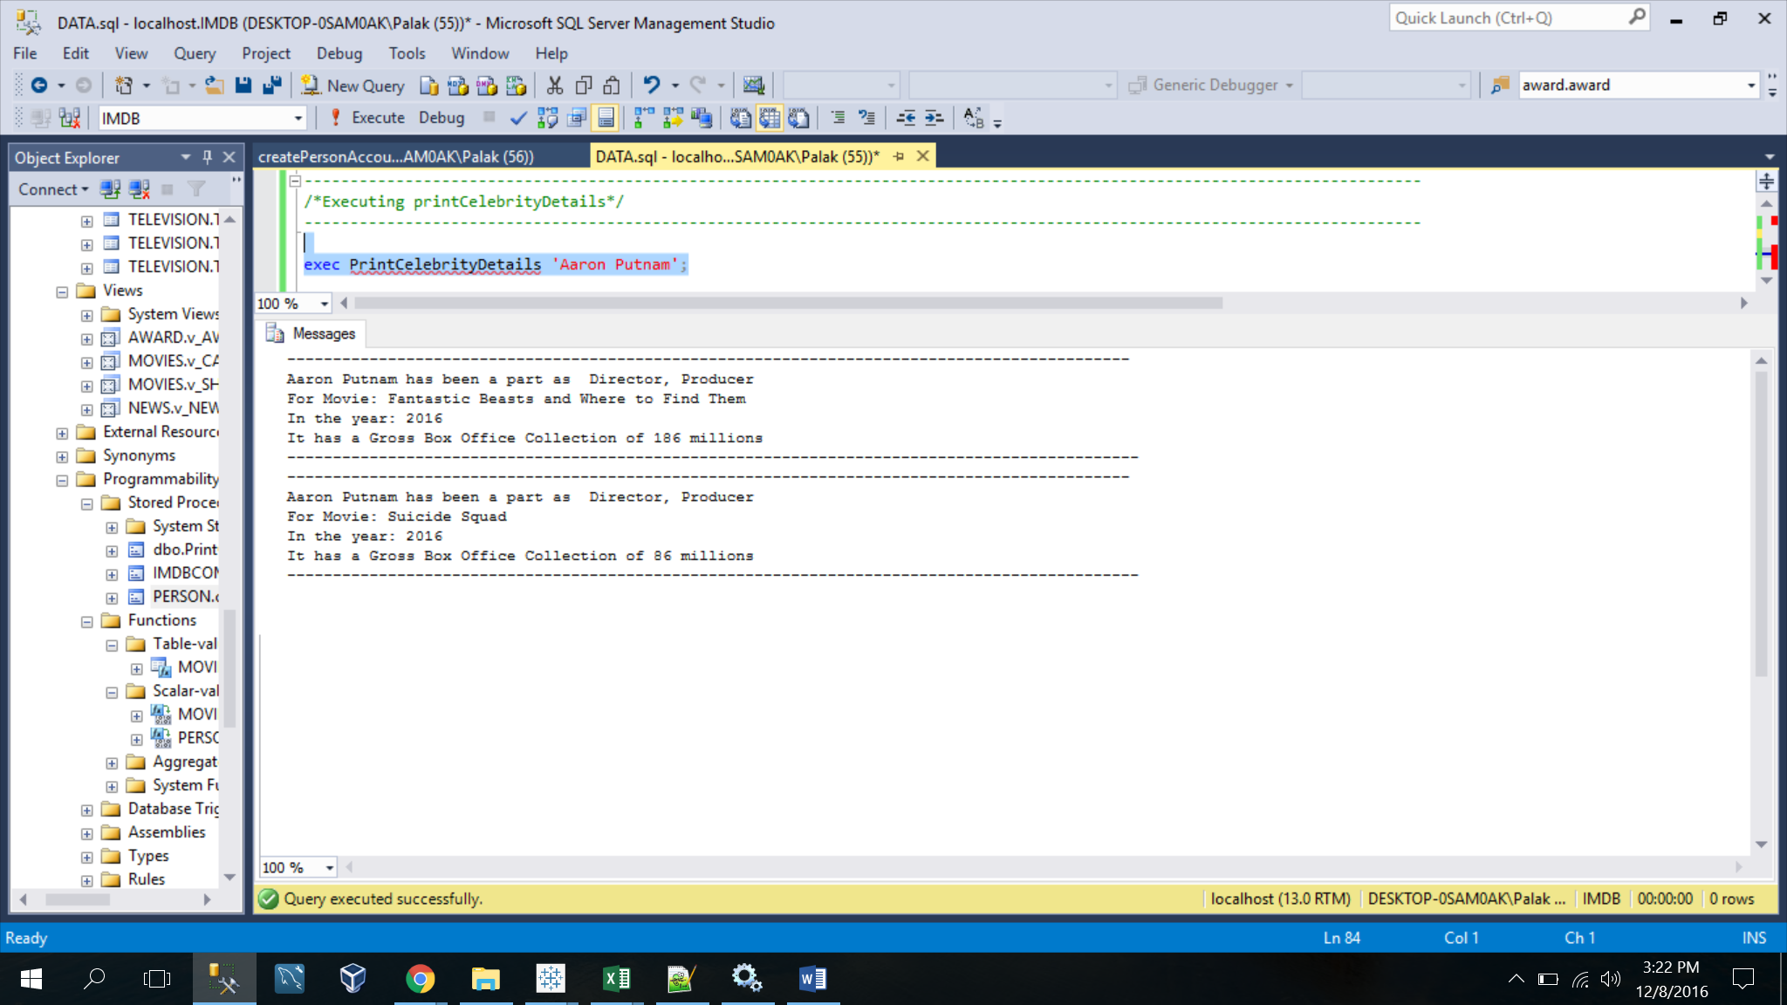

-----------------------------------------------------------------------------------------

/*Executing generateMovieReport*/

-----------------------------------------------------------------------------------------

|  |
| --- |
| USE [IMDB]  GO  /****** Object: StoredProcedure [dbo].[generateMovieReport] Script Date: 12/8/2016 5:12:39 PM ******/  SET ANSI_NULLS ON  GO  SET QUOTED_IDENTIFIER ON  GO  ALTER PROCEDURE [dbo].[generateMovieReport]  AS  BEGIN  SET NOCOUNT ON;  DECLARE  @MovieID INT,  @MovieName VARCHAR(50),  @LANGUAGE VARCHAR(50),  @CERTIFICATE VARCHAR(50),  @MESSAGE VARCHAR(100),  @DISKTYPE VARCHAR(50),  @LOCATION VARCHAR(50),  @TRAILERNAME VARCHAR(50),  @SOUNDMIXNAME VARCHAR(50),  @PRODUCTIONAME VARCHAR(50);  PRINT '--------TECHNICAL DETIALS OF MOVIE REPORT FOR 2016 --------';  DECLARE MOVIE_CURSOR CURSOR FOR  SELECT M.MovieID, M.Name FROM MOVIES.Movie M WHERE M.MovieYear = 2016 ORDER BY M.MovieID;  OPEN MOVIE_CURSOR  FETCH NEXT FROM MOVIE_CURSOR INTO @MovieID,@MovieName  WHILE @@FETCH_STATUS = 0  BEGIN  PRINT ' '  PRINT 'MOVIE:'+@MovieName  --LANGUAGE  SELECT @message = '-- LANGUAGES: ' +  @MovieName    PRINT @message  DECLARE LANGUAGE_CURSOR CURSOR FOR  SELECT L.Language FROM MOVIES.Language L, MOVIES.ReleaseLanguage RL, MOVIES.Movie M  WHERE L.LanguageID =RL.LanguageID AND RL.MovieID = M.MovieID AND M.Name=@MovieName;    OPEN LANGUAGE_CURSOR  FETCH NEXT FROM LANGUAGE_CURSOR INTO @LANGUAGE  IF @@FETCH_STATUS <> 0  PRINT ' <<None>>'    WHILE @@FETCH_STATUS = 0  BEGIN    SELECT @message = ' ' + @LANGUAGE  PRINT @message  FETCH NEXT FROM LANGUAGE_CURSOR INTO @LANGUAGE  END  --CERTIFICATE  PRINT '-- CERTIFICATE: '  DECLARE CERTIFICATE_CURSOR CURSOR FOR    SELECT C.CertificateName  FROM MOVIES.Certificate C, MOVIES.Movie M  WHERE C.CertificateID = M.CertificateID AND M.Name = @MovieName    OPEN CERTIFICATE_CURSOR  FETCH NEXT FROM CERTIFICATE_CURSOR INTO @CERTIFICATE  IF @@FETCH_STATUS <> 0  PRINT ' <<None>>'    WHILE @@FETCH_STATUS = 0  BEGIN    SELECT @message = ' ' + @CERTIFICATE  PRINT @message  FETCH NEXT FROM CERTIFICATE_CURSOR INTO @CERTIFICATE  END  --MOIVIEDISKTYPE  PRINT '-- MOVIE DISK TYPE: '  DECLARE MOVIEDISKTYPE_CURSOR CURSOR FOR    SELECT DISTINCT DR.DiskType FROM  MOVIES.DiskTypeRef DR RIGHT OUTER JOIN MOVIES.MovieOrTVDiskType MTR ON DR.DiskTypeID = MTR.DiskTypeID  RIGHT OUTER JOIN MOVIES.Movie M ON M.MovieID = MTR.MovieID AND M.Name = @MovieName WHERE DR.DiskType IS NOT NULL    OPEN MOVIEDISKTYPE_CURSOR  FETCH NEXT FROM MOVIEDISKTYPE_CURSOR INTO @DISKTYPE  IF @@FETCH_STATUS <> 0  PRINT ' <<None>>'    WHILE @@FETCH_STATUS = 0  BEGIN    SELECT @message = ' ' + @DISKTYPE  PRINT @message  FETCH NEXT FROM MOVIEDISKTYPE_CURSOR INTO @DISKTYPE  END  --LOCATION  PRINT '-- FILMING LOCATIONS: '  DECLARE LOCATION_CURSOR CURSOR FOR    SELECT DISTINCT FL.Location FROM  MOVIES.FilmingLocation FL RIGHT OUTER JOIN MOVIES.MovieFilmingLocation ML ON FL.LocationID= ML.LocationID  RIGHT OUTER JOIN MOVIES.Movie M ON M.MovieID = ML.MovieID AND M.Name = @MovieName WHERE LocATION IS NOT NULL    OPEN LOCATION_CURSOR  FETCH NEXT FROM MOVIEDISKTYPE_CURSOR INTO @DISKTYPE  IF @@FETCH_STATUS <> 0  PRINT ' <<None>>'    WHILE @@FETCH_STATUS = 0  BEGIN    SELECT @message = ' ' + @LOCATION  PRINT @message  FETCH NEXT FROM LOCATION_CURSOR INTO @LOCATION  END  --TRAILER  PRINT '-- TRAILER: '  DECLARE TRAILER_CURSOR CURSOR FOR    SELECT DISTINCT MT.Name FROM  MOVIES.MovieTrailer MT RIGHT OUTER JOIN MOVIES.Movie M  ON MT.MovieID = M.MovieID AND M.Name = @MovieName WHERE MT.Name IS NOT NULL    OPEN TRAILER_CURSOR  FETCH NEXT FROM TRAILER_CURSOR INTO @TRAILERNAME  IF @@FETCH_STATUS <> 0  PRINT ' <<None>>'    WHILE @@FETCH_STATUS = 0  BEGIN    SELECT @message = ' ' + @TRAILERNAME  PRINT @message  FETCH NEXT FROM TRAILER_CURSOR INTO @TRAILERNAME  END  --SOUNDMIX  PRINT '-- SOUND MIX: '  DECLARE SOUNDMIX_CURSOR CURSOR FOR    SELECT DISTINCT SM.SoundMixName FROM  MOVIES.SoundMixRef SM RIGHT OUTER JOIN MOVIES.MovieTVSoundMix MTSM  ON MTSM.SoundMixID = SM.SoundMixID RIGHT OUTER JOIN MOVIES.Movie M  ON M.MovieID = MTSM.MovieID  AND M.Name = @MovieName  WHERE SM.SoundMixName IS NOT NULL    OPEN SOUNDMIX_CURSOR  FETCH NEXT FROM SOUNDMIX_CURSOR INTO @SOUNDMIXNAME  IF @@FETCH_STATUS <> 0  PRINT ' <<None>>'    WHILE @@FETCH_STATUS = 0  BEGIN    SELECT @message = ' ' + @SOUNDMIXNAME  PRINT @message  FETCH NEXT FROM SOUNDMIX_CURSOR INTO @SOUNDMIXNAME  END  --PRODUCTION  PRINT '-- PRODUCTION HOUSE: '  DECLARE PRODUCTION_CURSOR CURSOR FOR    SELECT DISTINCT P.ProductioName FROM  MOVIES.ProductionHouse P RIGHT OUTER JOIN MOVIES.ProductionForMovieOrTV PM  ON P.ProductionID= PM.ProductionID  RIGHT OUTER JOIN MOVIES.Movie M  ON M.MovieID = PM.MovieID  AND M.Name = 'Arrival'  WHERE P.ProductioName IS NOT NULL    OPEN PRODUCTION_CURSOR  FETCH NEXT FROM PRODUCTION_CURSOR INTO @PRODUCTIONAME  IF @@FETCH_STATUS <> 0  PRINT ' <<None>>'    WHILE @@FETCH_STATUS = 0  BEGIN    SELECT @message = ' ' +@PRODUCTIONAME  PRINT @message  FETCH NEXT FROM PRODUCTION_CURSOR INTO @PRODUCTIONAME  END  CLOSE PRODUCTION_CURSOR  DEALLOCATE PRODUCTION_CURSOR    CLOSE SOUNDMIX_CURSOR  DEALLOCATE SOUNDMIX_CURSOR    CLOSE TRAILER_CURSOR  DEALLOCATE TRAILER_CURSOR    CLOSE LOCATION_CURSOR  DEALLOCATE LOCATION_CURSOR      CLOSE MOVIEDISKTYPE_CURSOR  DEALLOCATE MOVIEDISKTYPE_CURSOR    CLOSE CERTIFICATE_CURSOR  DEALLOCATE CERTIFICATE_CURSOR      CLOSE LANGUAGE_CURSOR  DEALLOCATE LANGUAGE_CURSOR  -- Get the next vendor.  FETCH NEXT FROM MOVIE_CURSOR  INTO @MovieID,@MovieName    END  CLOSE MOVIE_CURSOR;  DEALLOCATE MOVIE_CURSOR;  END; |

EXEC generateMovieReport;

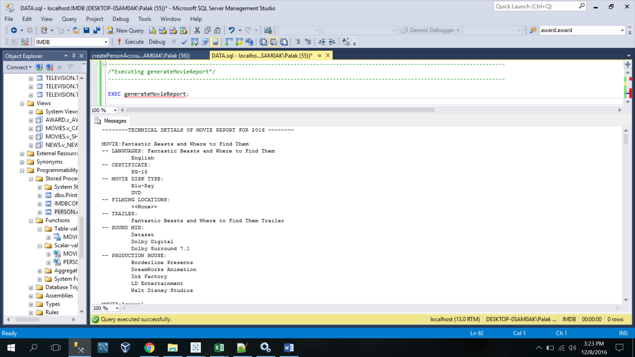

-----------------------------------------------------------------------------------------

/*Executing ufnDECODE()*/

-----------------------------------------------------------------------------------------

|  |
| --- |
| CREATE FUNCTION Movies.ufnDECODE(@AMOUNT_DIFF INTEGER)  RETURNs NVARCHAR(100)  AS  BEGIN  RETURN CASE WHEN @AMOUNT_DIFF>0 THEN 'Profit'  ELSE 'Loss' END  END |

SELECT Movies.ufnDECODE(-66) AS RESULT;

SELECT Movies.ufnDECODE(12) AS RESULT;

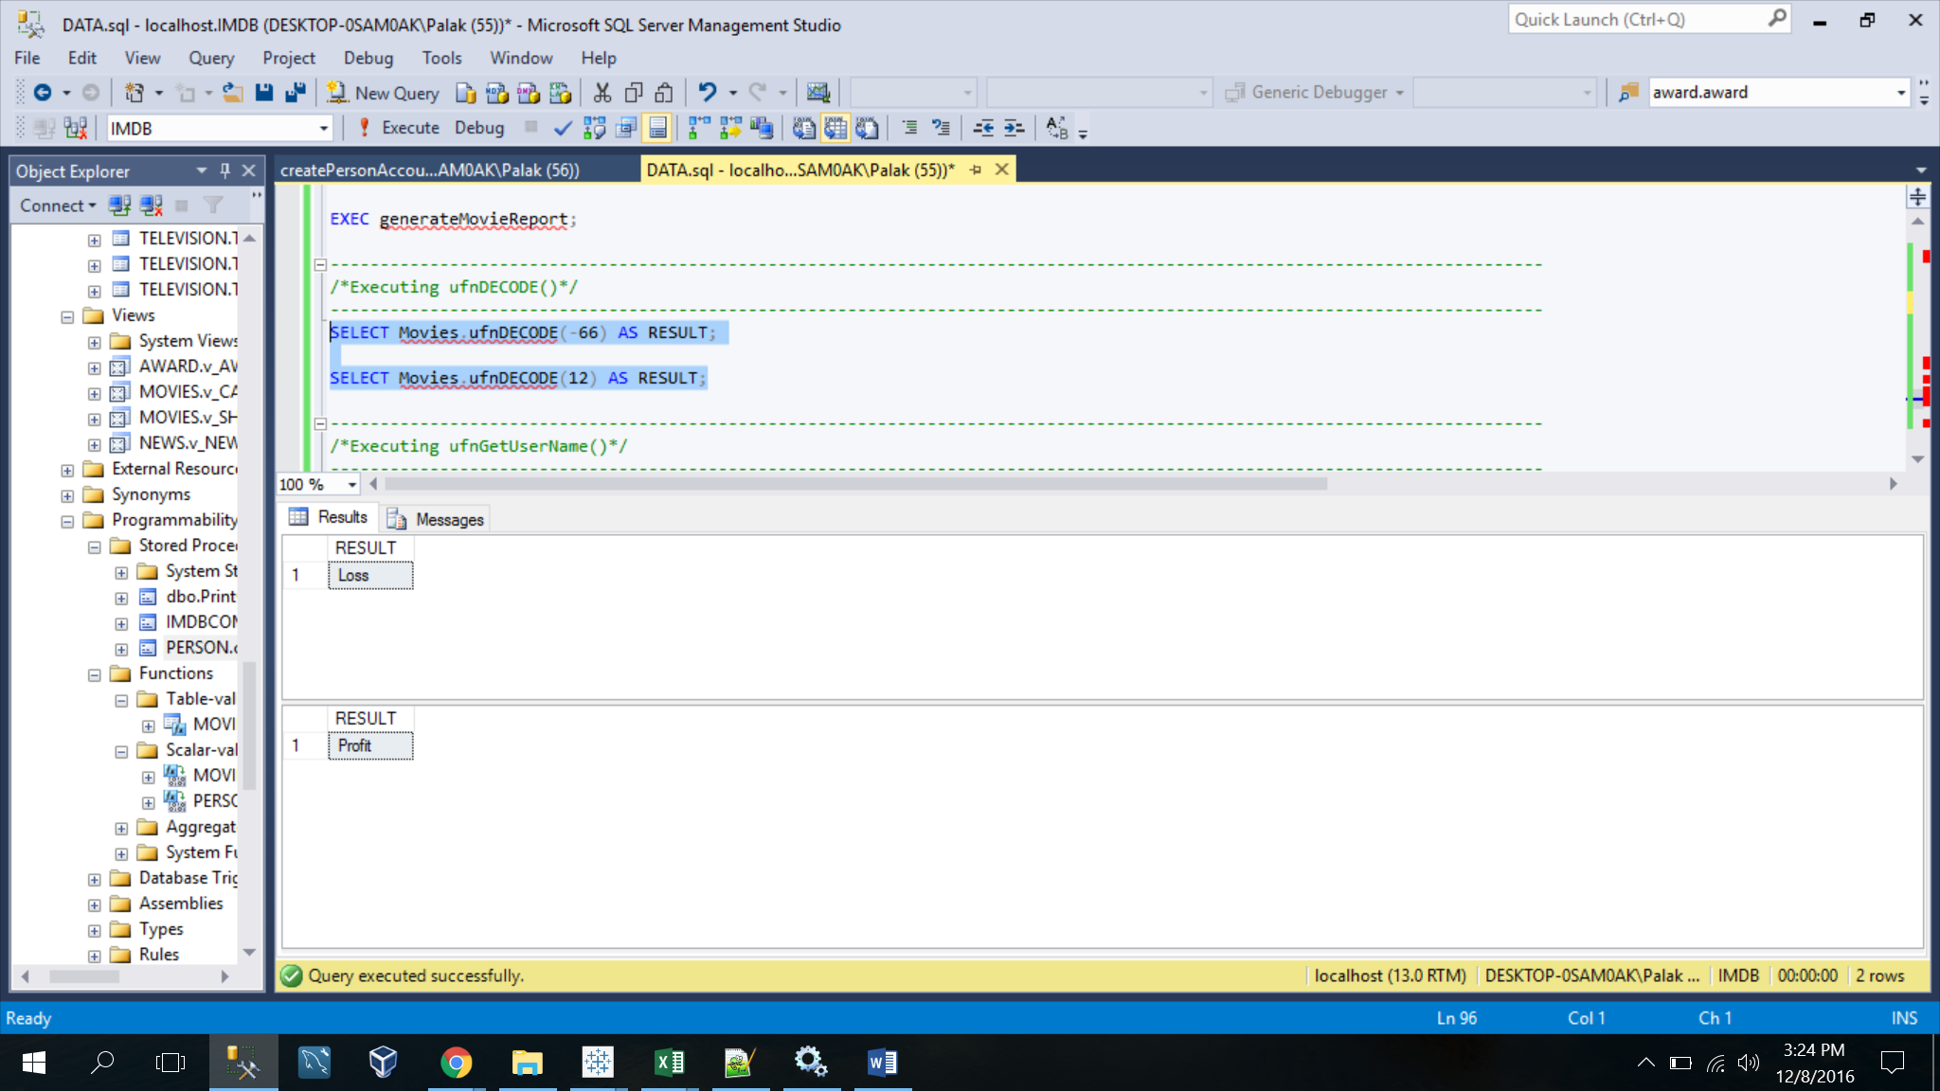

-----------------------------------------------------------------------------------------

/*Executing ufnGetUserName()*/

-----------------------------------------------------------------------------------------

|  |
| --- |
| CREATE FUNCTION PERSON.ufnGetUserName(@EmailAddress VARCHAR(50))  RETURNS VARCHAR(10)  AS  -- Returns the USERNAME ON THE BASIS OF EMAIL ADDRESS  BEGIN  DECLARE @ret VARCHAR(10);    SET @ret = SUBSTRING(@EmailAddress,1,CHARINDEX('@',@EmailAddress)-1);    IF(LEN(@ret) > 10)  SET @ret = LEFT(@ret, 10);  IF (@ret IS NULL)  SET @ret = 'dummy123';    RETURN @ret;  END; |

SELECT PERSON.ufnGetUserName('agrawal.pala@husky.neu.edu');

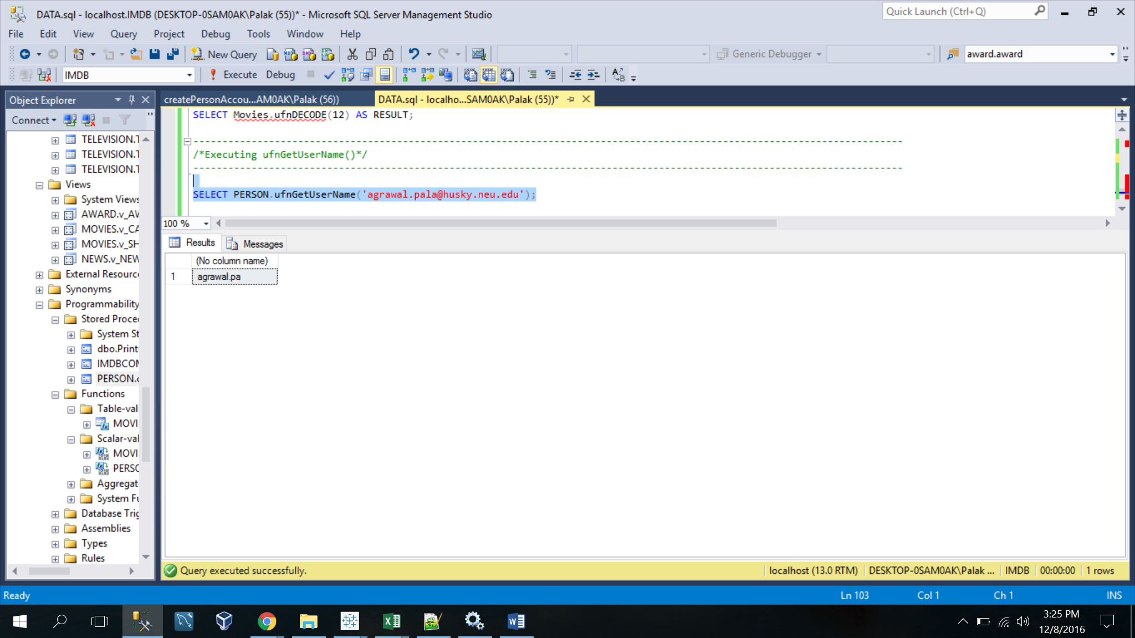

-----------------------------------------------------------------------------------------

/*Executing ufnPopularMoviesByGenre()*/

-----------------------------------------------------------------------------------------

|  |
| --- |
| CREATE FUNCTION MOVIES.ufnPopularMoviesByGenre()  RETURNS TABLE  AS  RETURN (  SELECT MG.Genre AS GENRE, SUM(BOC.CollectionAmount) AS BOX_OFFICE_COLLECTION  FROM MOVIES.BoxOfficeCollectionOfMovie BOC,  MOVIES.Movie MM,  MOVIES.Genre MG,  MOVIES.MovieTVGenre MTG  WHERE MM.MovieID = MTG.MovieID AND  MG.GenreID = MTG.GenreID AND  BOC.MovieID = MM.MovieID  GROUP BY MG.Genre  ); |

SELECT * from MOVIES.ufnPopularMoviesByGenre();

